CSE 331 Spring 2026
Homework 4

SEED Labs
Firewall Exploration

Acknowledgement:
I confirm that this submission, including all code and figures, is entirely my own work.

Full Name: ___尤晟喧______
Student ID: _____R32314015____
Date: ____2026.4.28__________

Complete this template based on the manual provided. Answer in English. (Homework_4_Manual_Firewall.pdf, available in both English and Chinese).
3.1 Task 1.A: Implement a Simple Kernel Module
Screenshot for Task 1.A (Replace the screenshot below with your own screenshot):
Show your screenshot of Hello World! and Bye-bye World!. shown in the dmesg log.
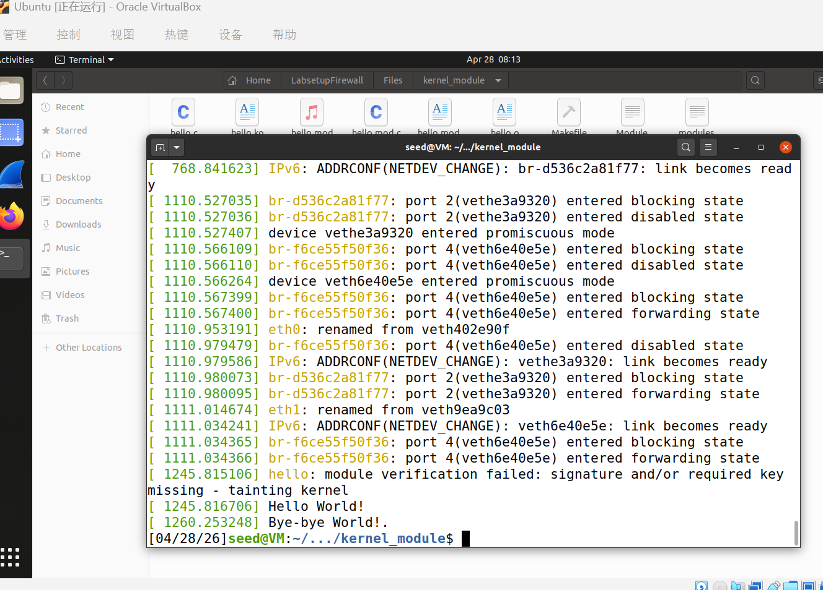
Figure 1 dmesg log showing hello world and bye-bye world

3.2 Task 1.B: Implement a Simple Firewall Using Netfilter
Screenshot for Task 1.B Part 1(Replace the screenshot below with your own screenshot):
Part 1. Show that your firewall is working by providing the screenshot below. It should show that the packets intended for 8.8.8.8 are dropped. You can see this using dmesg instruction.
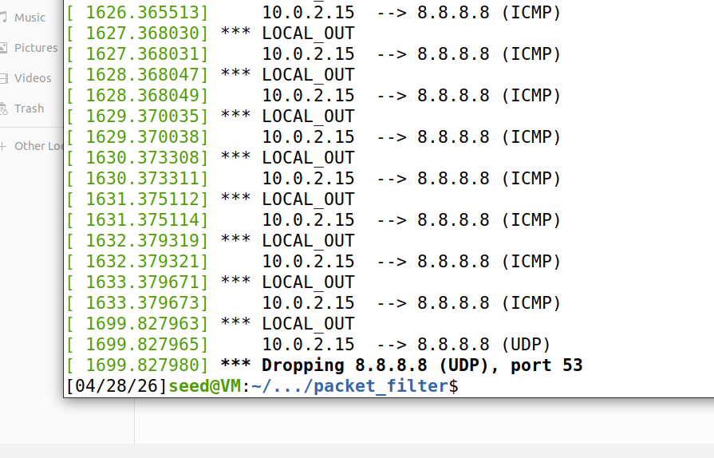
Figure 2 dmesg log showing packets intended for 8.8.8.8 are dropped

Part 2. Hook the printInfo function to all of the netfilter hooks.
– Question 1. Explain at what condition will the hook function for NF_INET_LOCAL_IN be invoked.
Answer:The NF_INET_LOCAL_IN hook function is invoked when an incoming packet is destined specifically for the local machine itself (in this case, the firewall/router's own IP address). It triggers after the initial routing decision confirms the packet is not just passing through to another destination

Screenshot for Task 1.B Part 2(Replace the screenshot below with your own screenshot):
Show that you have hooked the printInfo function to all of the netfilter hooks. You can do this by running dig www.example.com, and check the dmesg logs.
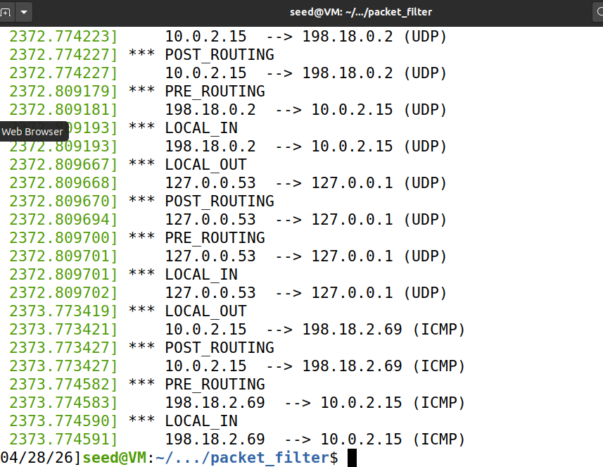
Figure 3 dmesg log showing the printInfo function is hooked to all hooks

You don’t need to complete Task 1.B part 3.

4.3 Task 2.A: Protecting the Router
– Question 2. Ask the questions below, after you have executed the iptables command in the lab manual.
- Can you ping the router? Answer: Yes
- Can you telnet into the router? Answer: No
- Explain the purpose of the following two rules in the lab manual:
iptables -A INPUT -p icmp --icmp-type echo-request -j ACCEPT
Answer:This rule appends (-A) an instruction to the INPUT chain to accept incoming ICMP packets, specifically those that are ping requests (echo-request).

iptables -A OUTPUT -p icmp --icmp-type echo-reply -j ACCEPT
Answer:This rule appends (-A) an instruction to the OUTPUT chain to accept outgoing ICMP packets, specifically those that are ping responses (echo-reply). Together, these two rules allow the router to receive and reply to pings, even if the default policies are set to DROP

4.4 Task 2.B: Protecting the Internal Network
– Question 3. Provide the rule(s) you used to enforce the following restrictions:
- Outside hosts cannot ping internal hosts.
- Outside hosts can ping the router.
- Internal hosts can ping outside hosts.
- All other packets between the internal and external networks should be blocked.
Answer (should be iptable instructions):
iptables -P FORWARD DROP

iptables -A FORWARD -s 192.168.60.0/24 -p icmp --icmp-type echo-request -j ACCEPT

iptables -A FORWARD -d 192.168.60.0/24 -p icmp --icmp-type echo-reply -j ACCEPT

Screenshot for task 2.B (Replace the screenshot below with your own screenshot):
Should show the rules displayed by running iptables -L -n in the router container.
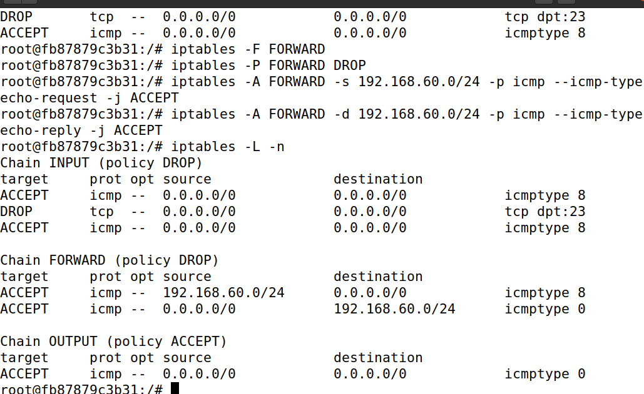
Figure 4 Rules for task 2.B
4.5 Task 2.C: Protecting the Internal Server
– Question 4. Provide the rules you used to enforce the restrictions in task 2.C.
Answer (should be iptable instructions):
iptables -P FORWARD DROP

iptables -A FORWARD -d 192.168.60.5 -p tcp --dport 23 -j ACCEPT

iptables -A FORWARD -s 192.168.60.5 -p tcp --sport 23 -j ACCEPT

iptables -A FORWARD -s 192.168.60.0/24 -d 192.168.60.0/24 -j ACCEPT

Screenshot for task 2.C (Replace the screenshot below with your own screenshot):
Should show the rules displayed by running iptables -L -n in the router container.
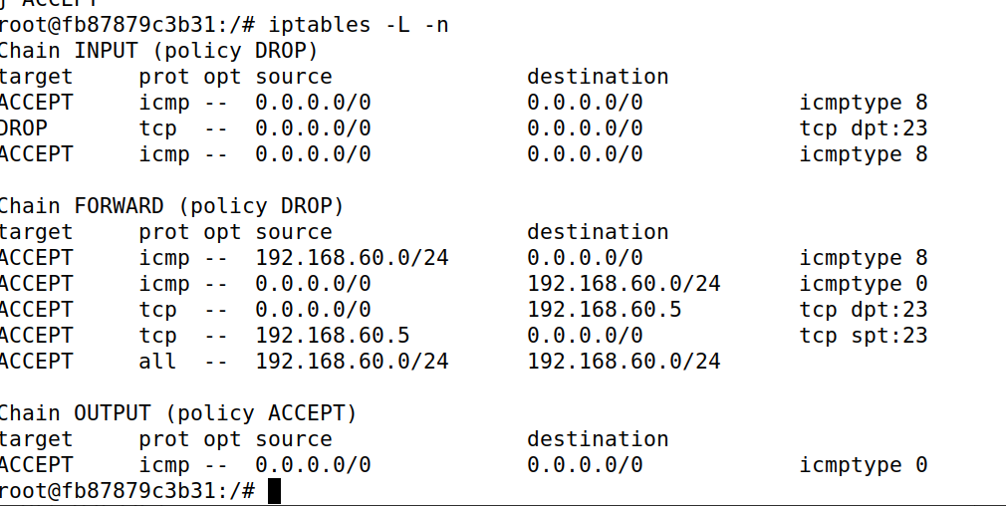
Figure 5 Rules for task 2.C

5.1 Task 3.A: Experiment with the Connection Tracking
– Question 5. How long is the ICMP connection state kept?
Answer: 30seconds

– Question 6. How long is the UDP connection state kept?
Answer: 30 seconds for unreplied UDP traffic, and it extends to 180 seconds if the connection becomes "ASSURED" .

– Question 7. How long is the TCP connection state kept?
Answer: 432,000 seconds for an ESTABLISHED TCP connection . Timeouts are significantly shorter for connection teardowns like TIME_WAIT.

Screenshot for task 3.A (Replace the screenshot below with your own screenshot):
Should show the conntrack logs for TCP connection.
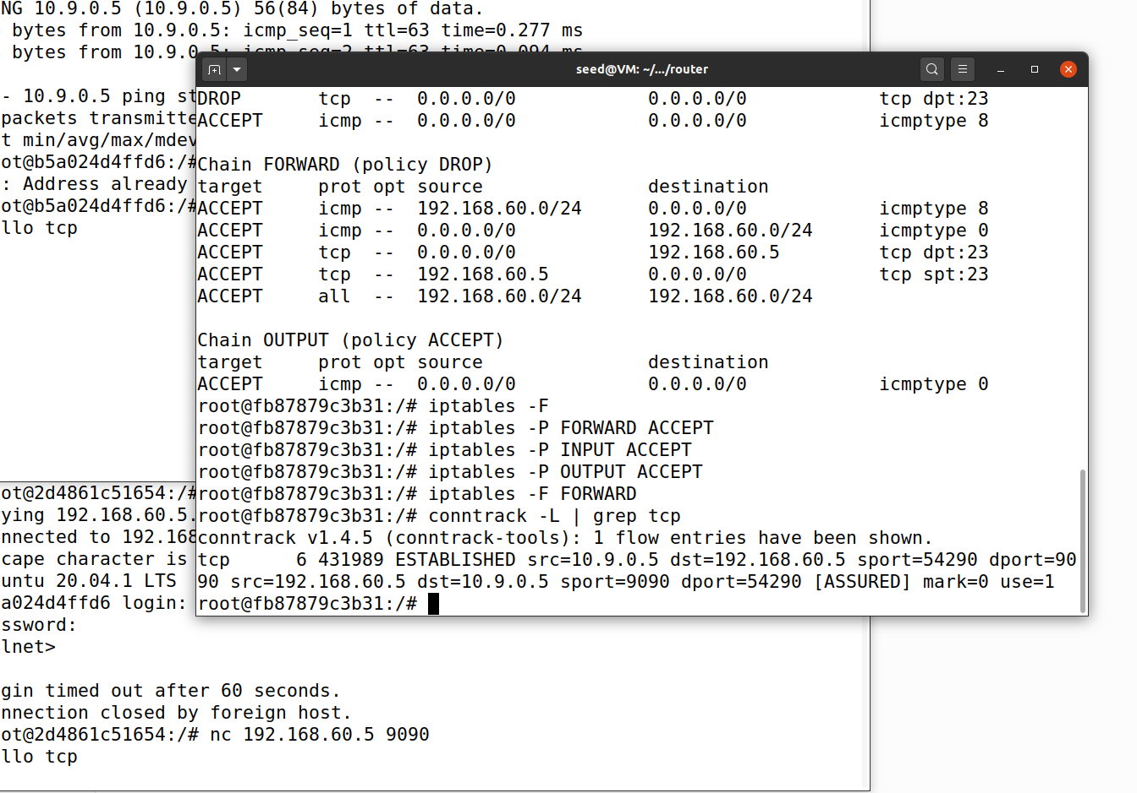
Figure 6 Conntrack logs for TCP connection
5.2 Task 3.B: Setting up a Stateful Firewall
– Question 8. Provide the rules you used to enforce the restrictions in task 3.B.
Answer (should be iptable instructions):
iptables -P FORWARD DROP
iptables -A FORWARD -m conntrack --ctstate ESTABLISHED,RELATED -j ACCEPT
iptables -A FORWARD -d 192.168.60.5 -p tcp --dport 23 --syn -m conntrack --ctstate NEW -j ACCEPT
iptables -A FORWARD -s 192.168.60.0/24 ! -d 192.168.60.0/24 -m conntrack --ctstate NEW -j ACCEPT
iptables -A FORWARD -s 192.168.60.0/24 -d 192.168.60.0/24 -m conntrack --ctstate NEW -j ACCEPT

– Question 9. How do you achieve the same goal without using the connection tracking mechanism? Describing your ideas would be fine, no actual instructions needed.
Answer: Without the conntrack mechanism, you must implement a stateless firewall. This requires explicitly writing rules for both directions of traffic for every permitted service. For TCP traffic, you would need to accept outgoing SYN packets and manually accept incoming response packets that have the ACK bit set (e.g., using --tcp-flags). This approach is more tedious, less secure (as attackers can spoof ACK flags to bypass rules), and particularly difficult for connectionless protocols like UDP and ICMP which lack explicit state flags entirely

Screenshot for task 3.B (Replace the screenshot below with your own screenshot):
Should show the rules displayed by running iptables -L -n in the router container.
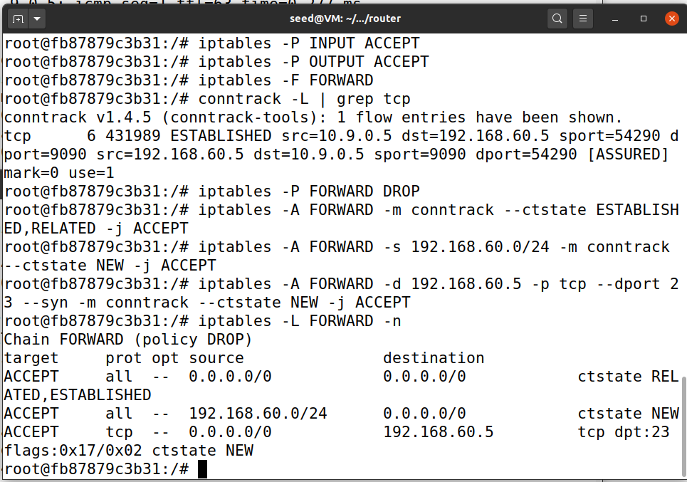
Figure 7 Rules for task 3.B

You don’t need to complete Task 4 and Task 5.

6 Submission
Convert the finished template to pdf and upload. Do not upload .docx or any other files.

